**Formal definition of the derivative as a limit**

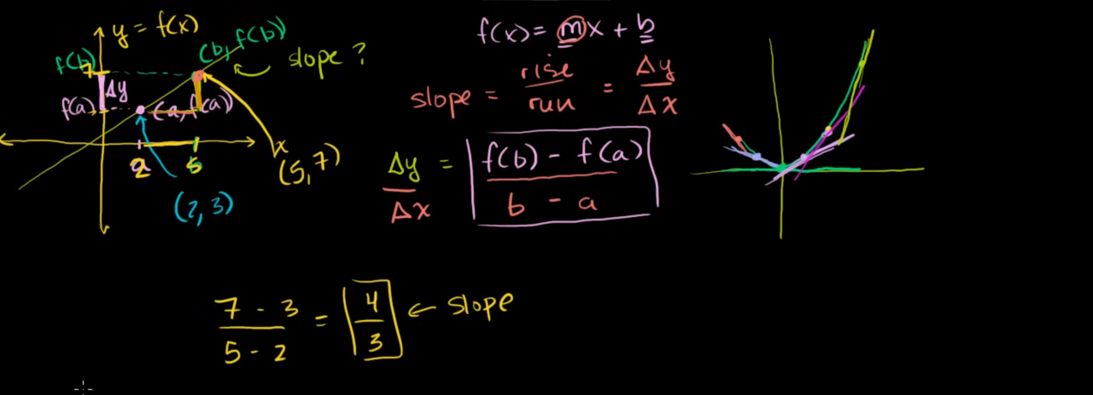

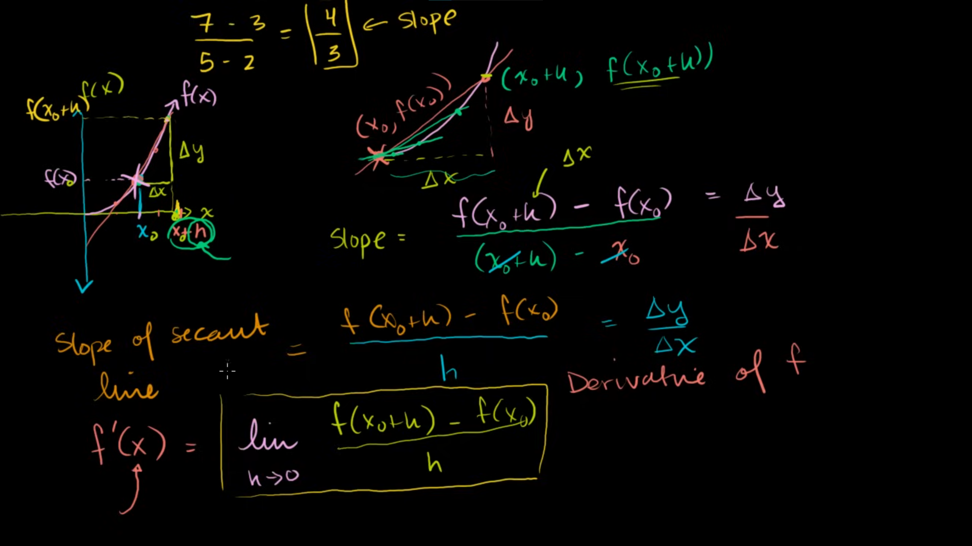

**Formal and alternate form of the derivative**

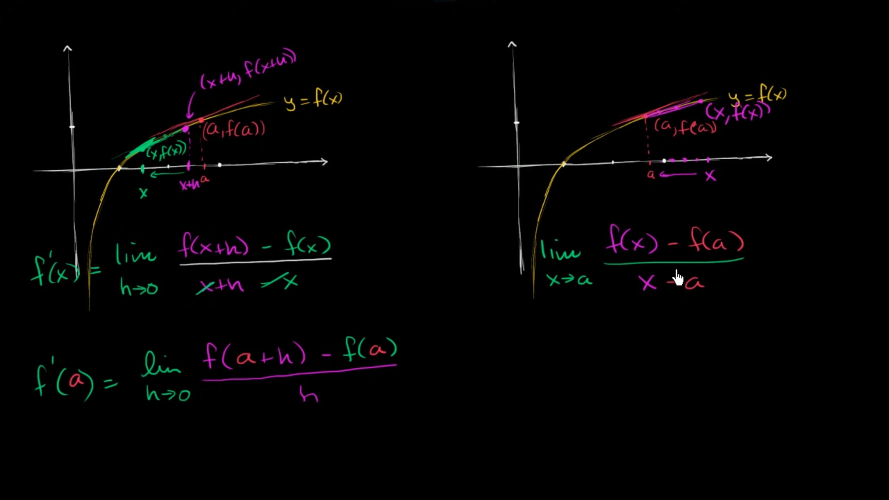

**Worked example: Derivative as a limit**

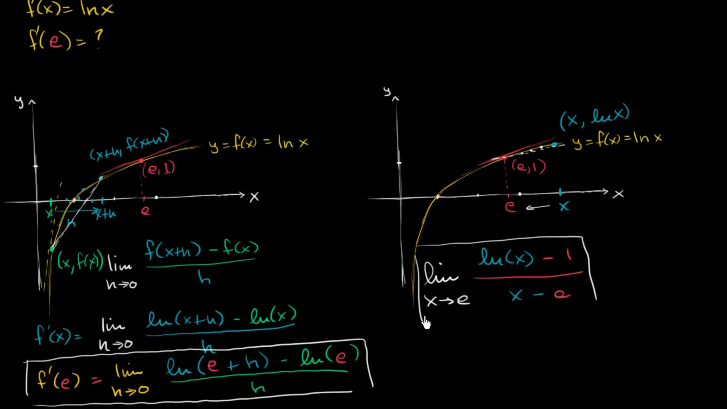

**Worked example: Derivative from limit expression**

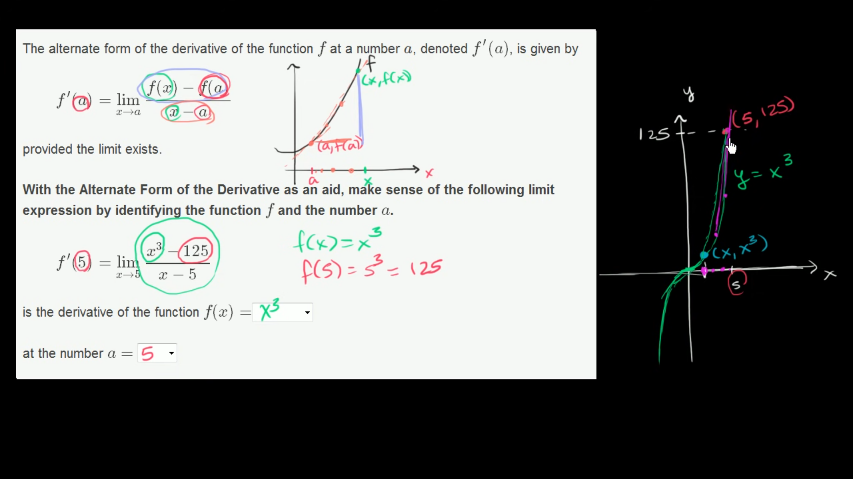

**The derivative of x² at x=3 using the formal definition**

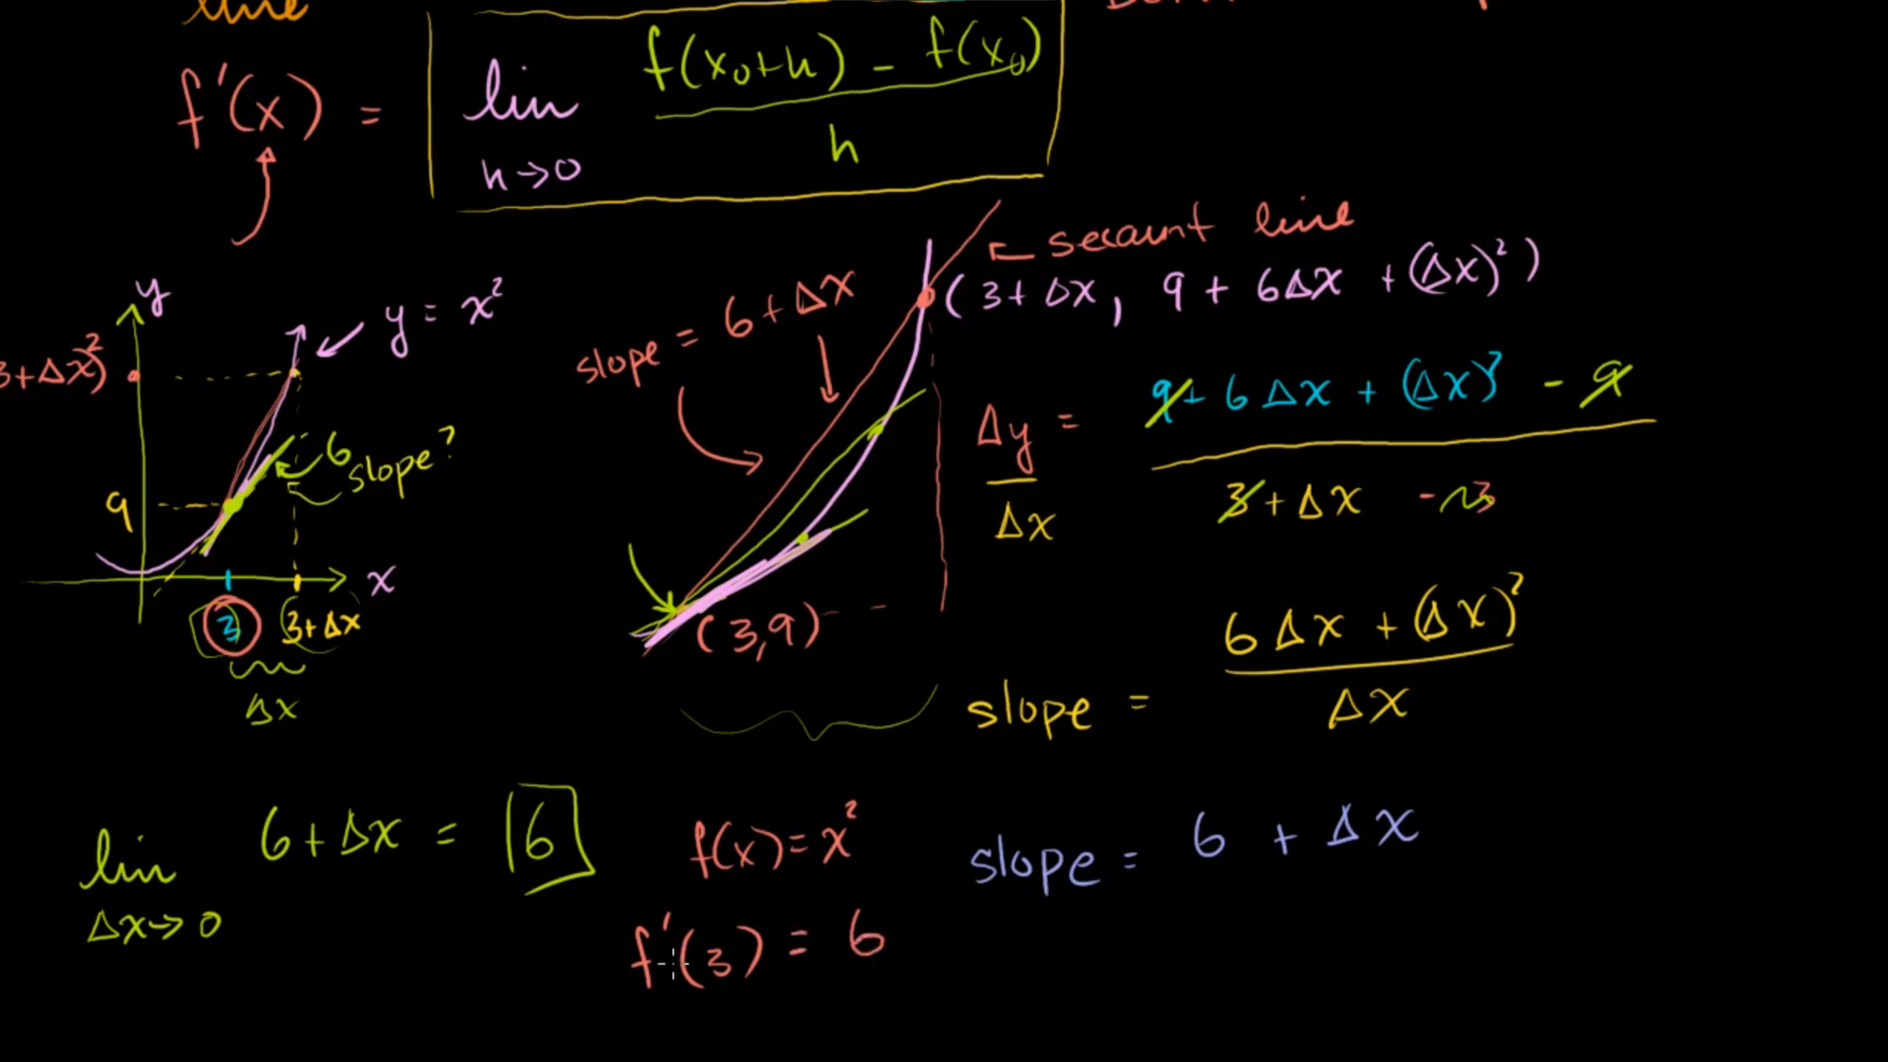

**The derivative of x² at any point using the formal definition**

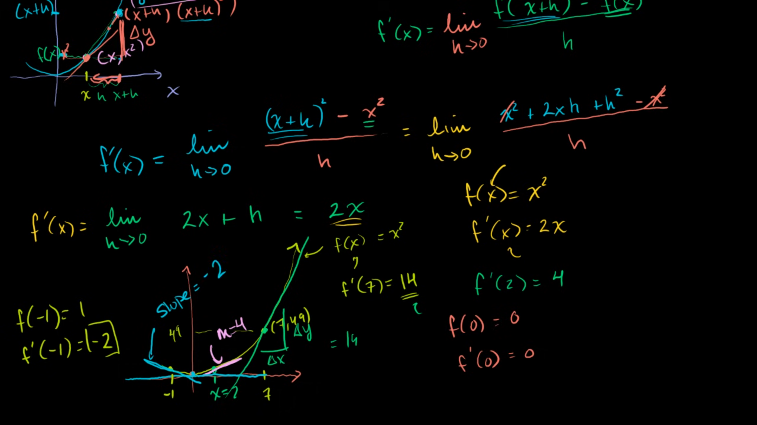

**Limit expression for the derivative of function (graphical)**

